Project 3.4 - GitOps Application Deployment using ArgoCD on Kubernetes

REPO : https://github.com/SnehalShinde11/gitops-nginx-app.git

Task 1 - Create Kubernetes Cluster
Set up a Kubernetes cluster that will host the application.
This cluster can be created using a managed service such as Amazon EKS or any Kubernetes environment.

For this, I am using the GKE cluster.
Cluster verification :
#kubectl cluster-info
#kubectl get nodes
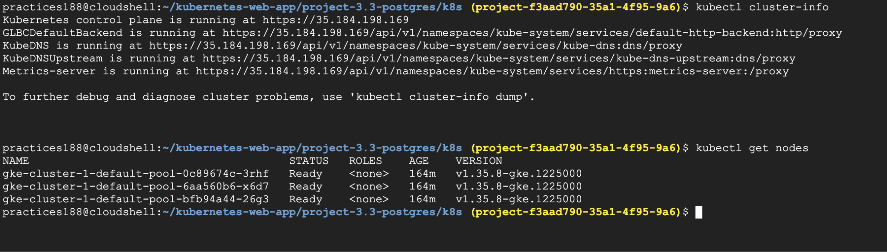

Task 2 - Install ArgoCD
Install ArgoCD in the Kubernetes cluster.
ArgoCD will act as the GitOps controller responsible for monitoring Git repositories and synchronizing application configurations.
We'll install ArgoCD into a dedicated namespace called argocd.
#kubectl create namespace argocd
#kubectl get namespace argocd

Install ArgoCD:
#kubectl apply -n argocd \
-f https://raw.githubusercontent.com/argoproj/argo-cd/stable/manifests/install.yaml

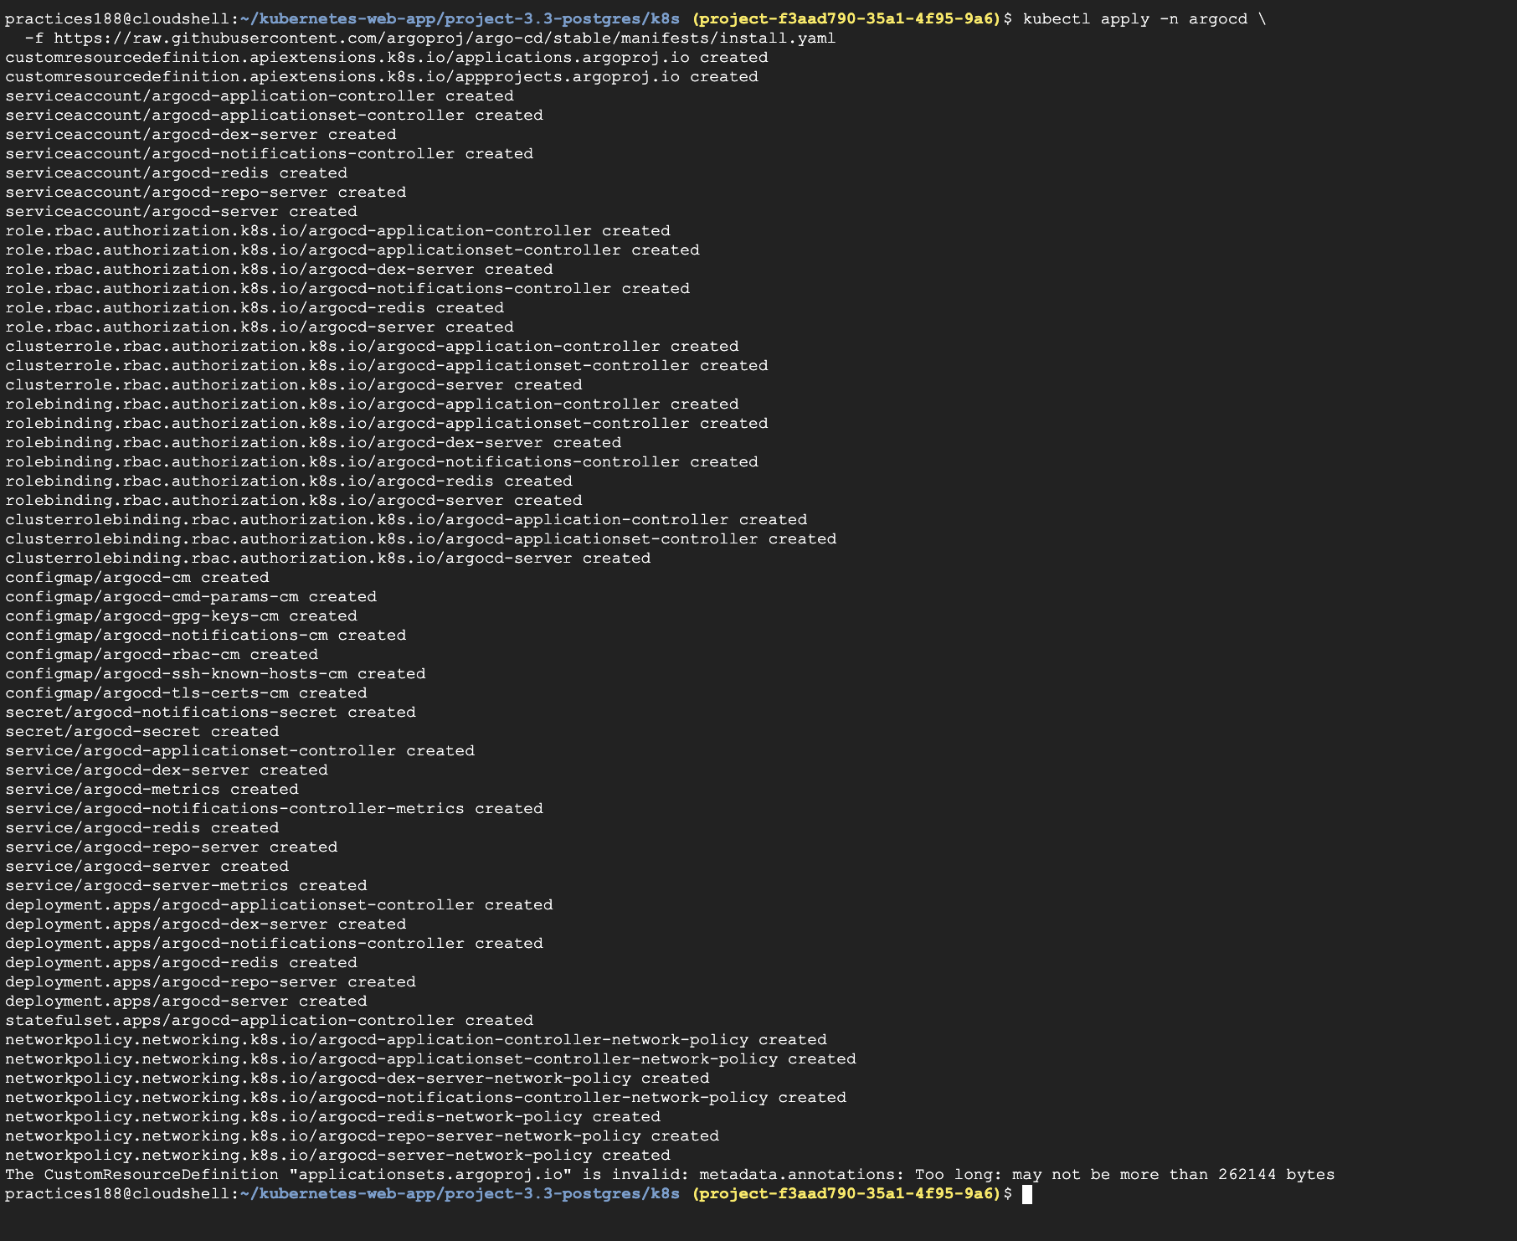
Then check the ArgoCD Pods:#kubectl get pods -n argocd

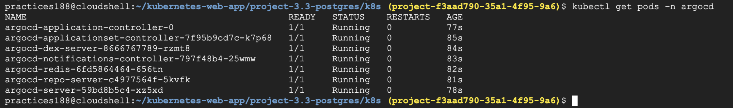
Now we need to access the ArgoCD dashboard.
Get ArgoCD Server Password:
#kubectl get secret argocd-initial-admin-secret -n argocd -o yaml
#echo '<base64-encoded-value>'| base64 -d

Or else :
#kubectl -n argocd get secret argocd-initial-admin-secret -o jsonpath='{.data.password}' | base64 -d
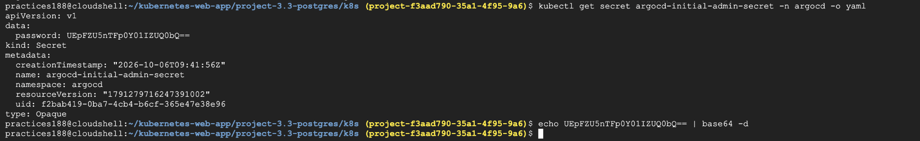

For our GKE cluster, we'll use port-forwarding. This is simple and doesn't create any external LoadBalancer.

Check #kubectl get svc argocd-server -n argocd
Your Service exposes:
80/TCP
443/TCP

Run:kubectl port-forward svc/argocd-server -n argocd 8080:80
Keep this terminal running.

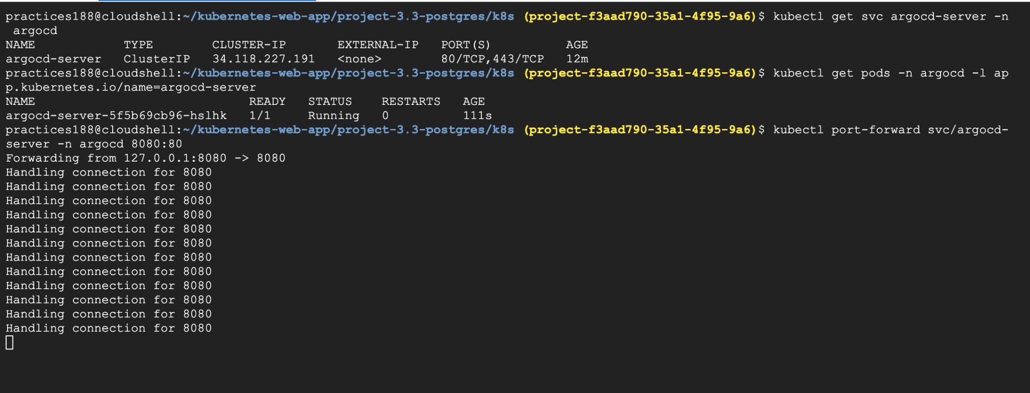

Then in Cloud Shell, click:
Web Preview → Change port → 8080
you should see the ArgoCD login screen.
Login:
Username: admin
Password: <your ArgoCD initial password>
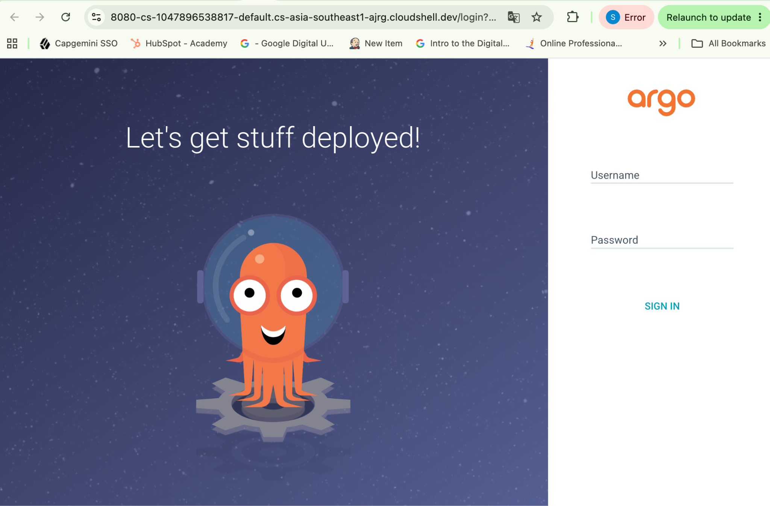

Task 3 - Prepare Git Repository
Create a Git repository that contains Kubernetes deployment configurations.
This repository should include files that define:
﻿﻿Application deployment
﻿﻿Kubernetes service
﻿﻿Container image configuration

Go to GitHub and create a new repository. : gitops-nginx-app
Let's create the Kubernetes manifests locally and then push them to your GitHub repository.
Run:
#cd ~/kubernetes-web-app
#mkdir -p project-3.4-gitops-nginx/k8s
#cd project-3.4-gitops-nginx

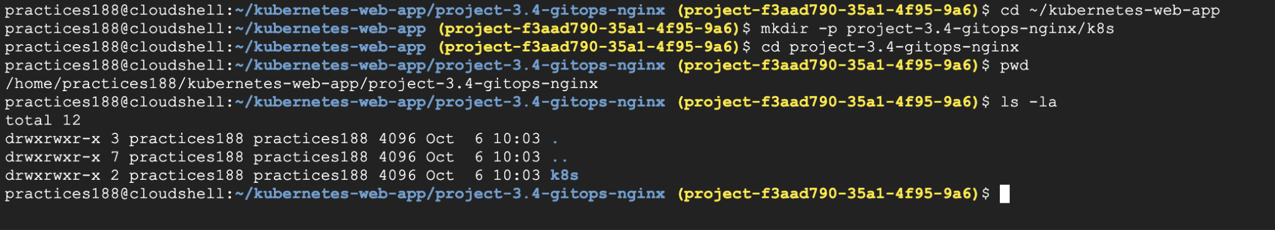

Create the deployment :
We'll use nginx:1.27-alpine and start with 2 replicas so we can demonstrate Kubernetes deployment management.

Create the Kubernetes Service:
Push this files to repo :
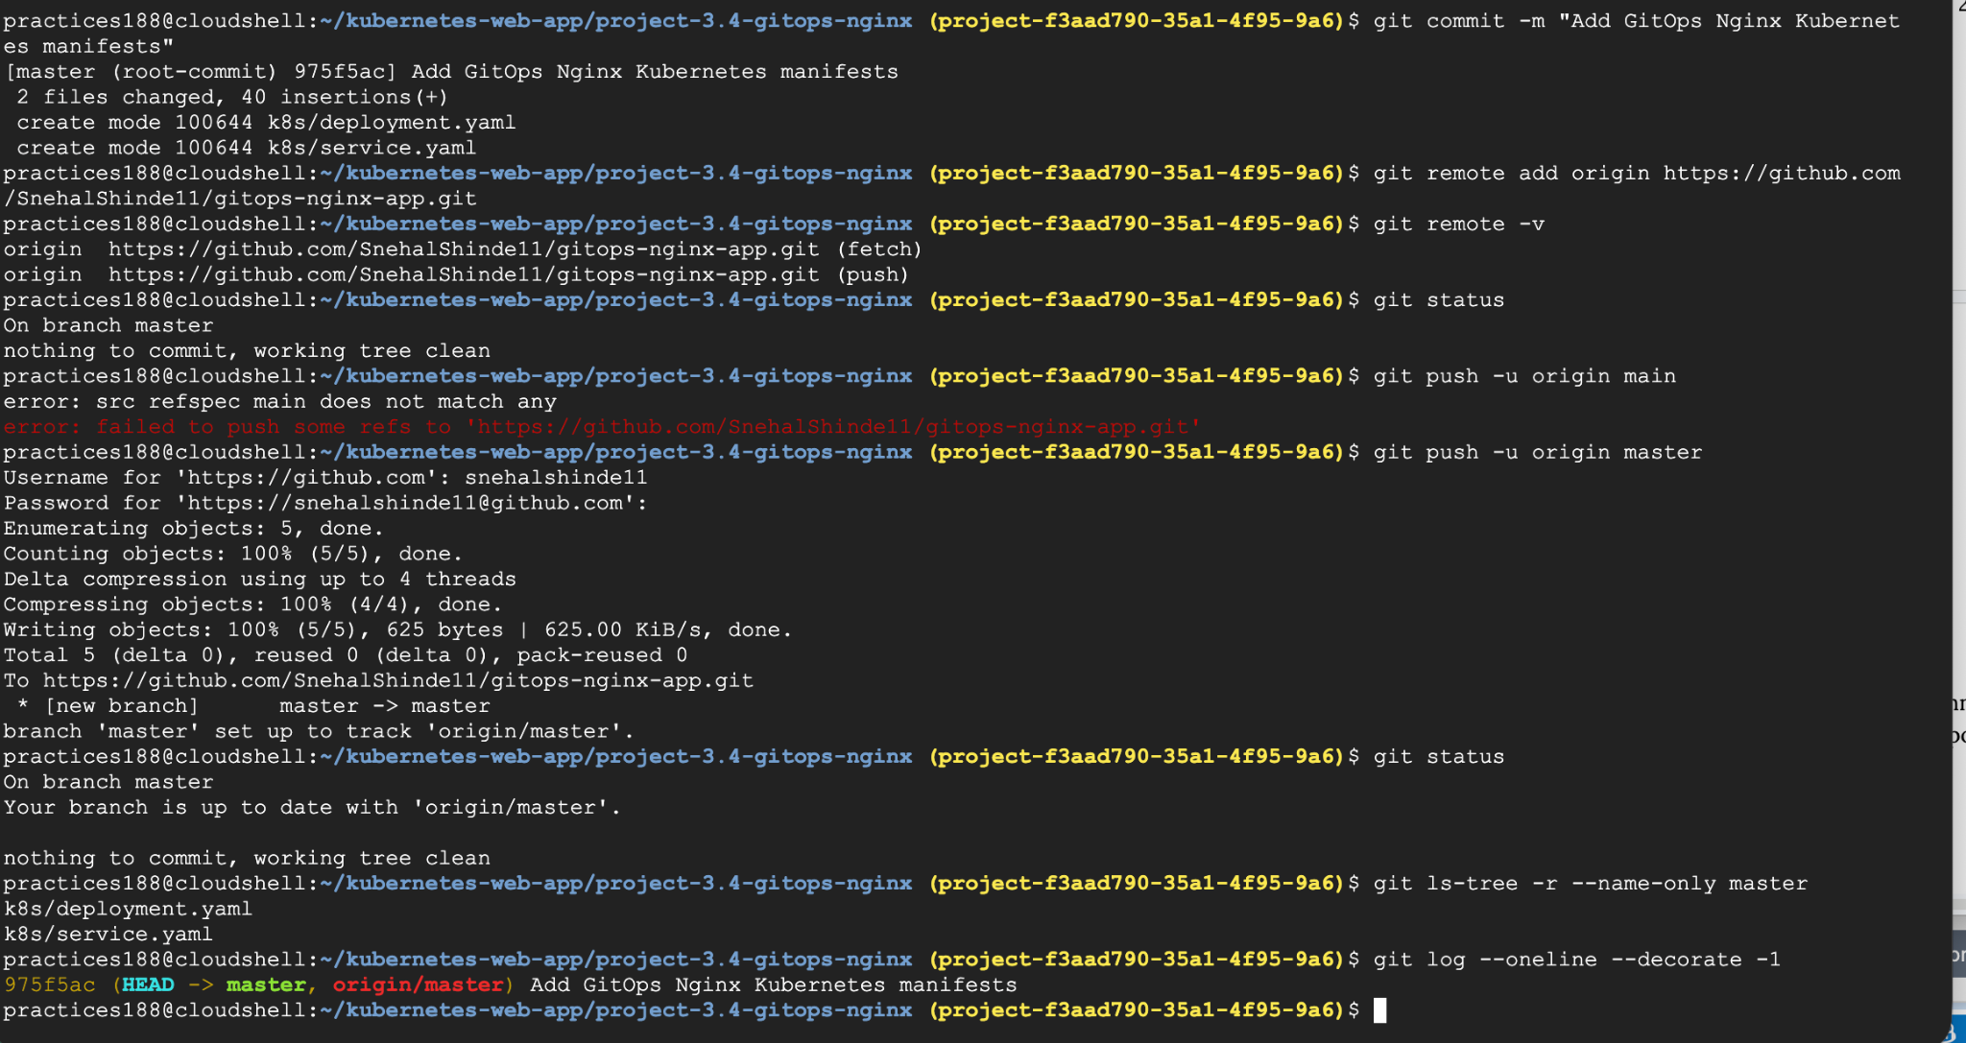

Task 4 - Configure ArgoCD Application
Configure an ArgoCD application that connects to the Git repository.
This configuration tells ArgoCD which repository and deployment configuration it should monitor.

-we'll configure it through the UI.
1. Open ArgoCD
You should still have the ArgoCD dashboard open.
Go to:
Applications → + NEW APP

2. General
Enter:
Field | Value
Application Name | gitops-nginx
Project Name | default
Sync Policy | Automatic
If you see options under Automatic Sync, enable:
Prune Resources
Self Heal

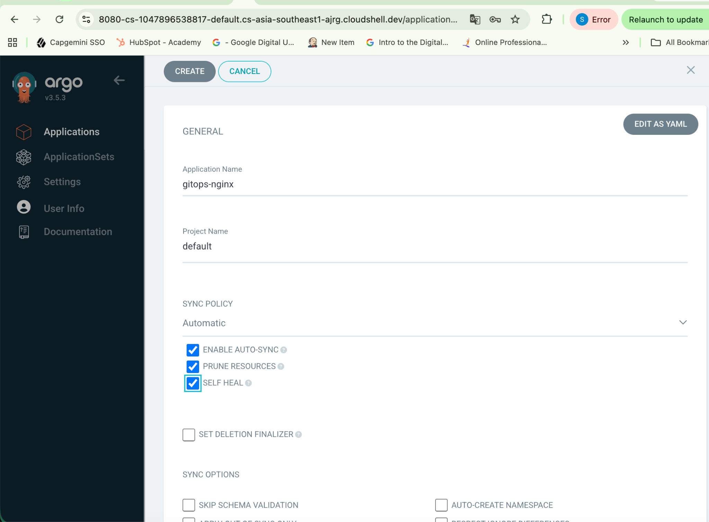

3. Source
Under Source, enter:
Repository URL:https://github.com/SnehalShinde11/gitops-nginx-app.git
Revision: master
Path:k8s

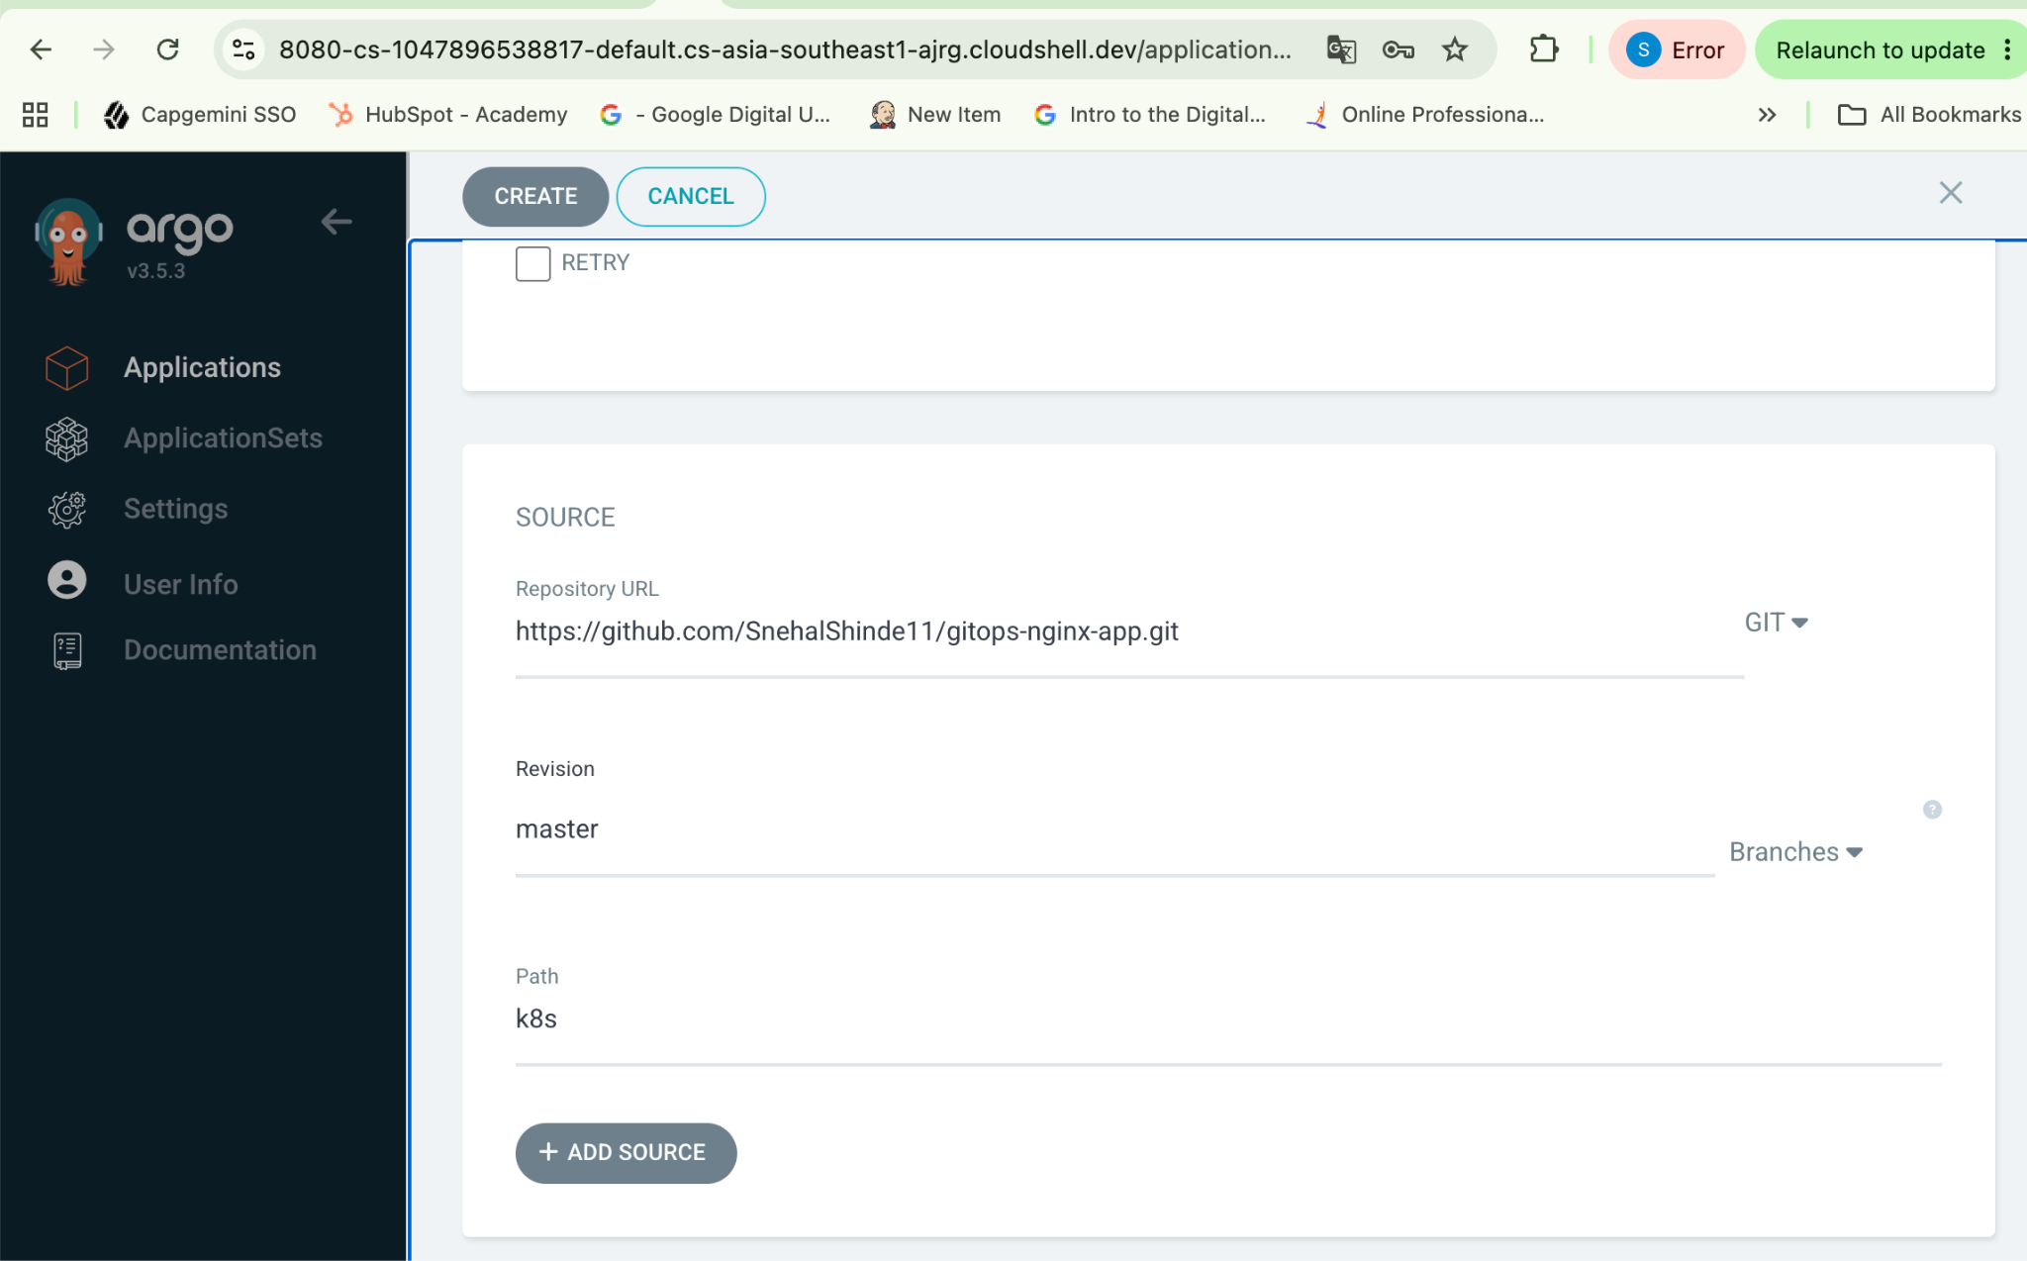

4. Destination
For Cluster URL, select or enter:
https://kubernetes.default.svc
For Namespace, enter:
gitops-nginx
If ArgoCD gives you a Create Namespace option, enable it.
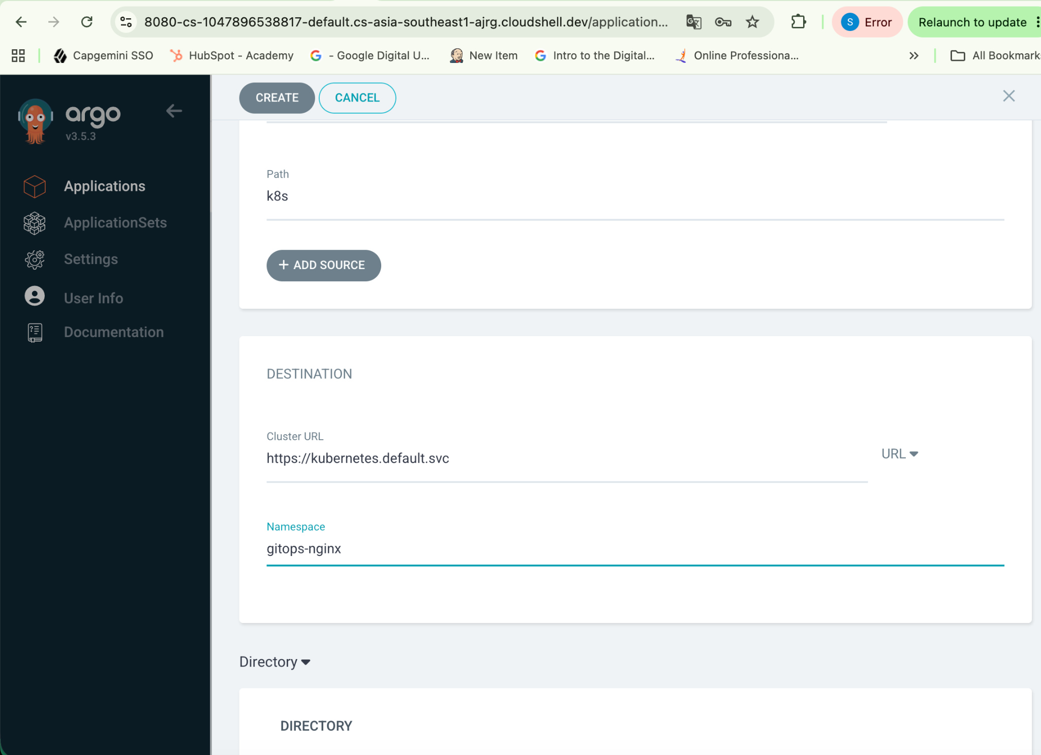

In Sync Option : Enable Auto create namespace:
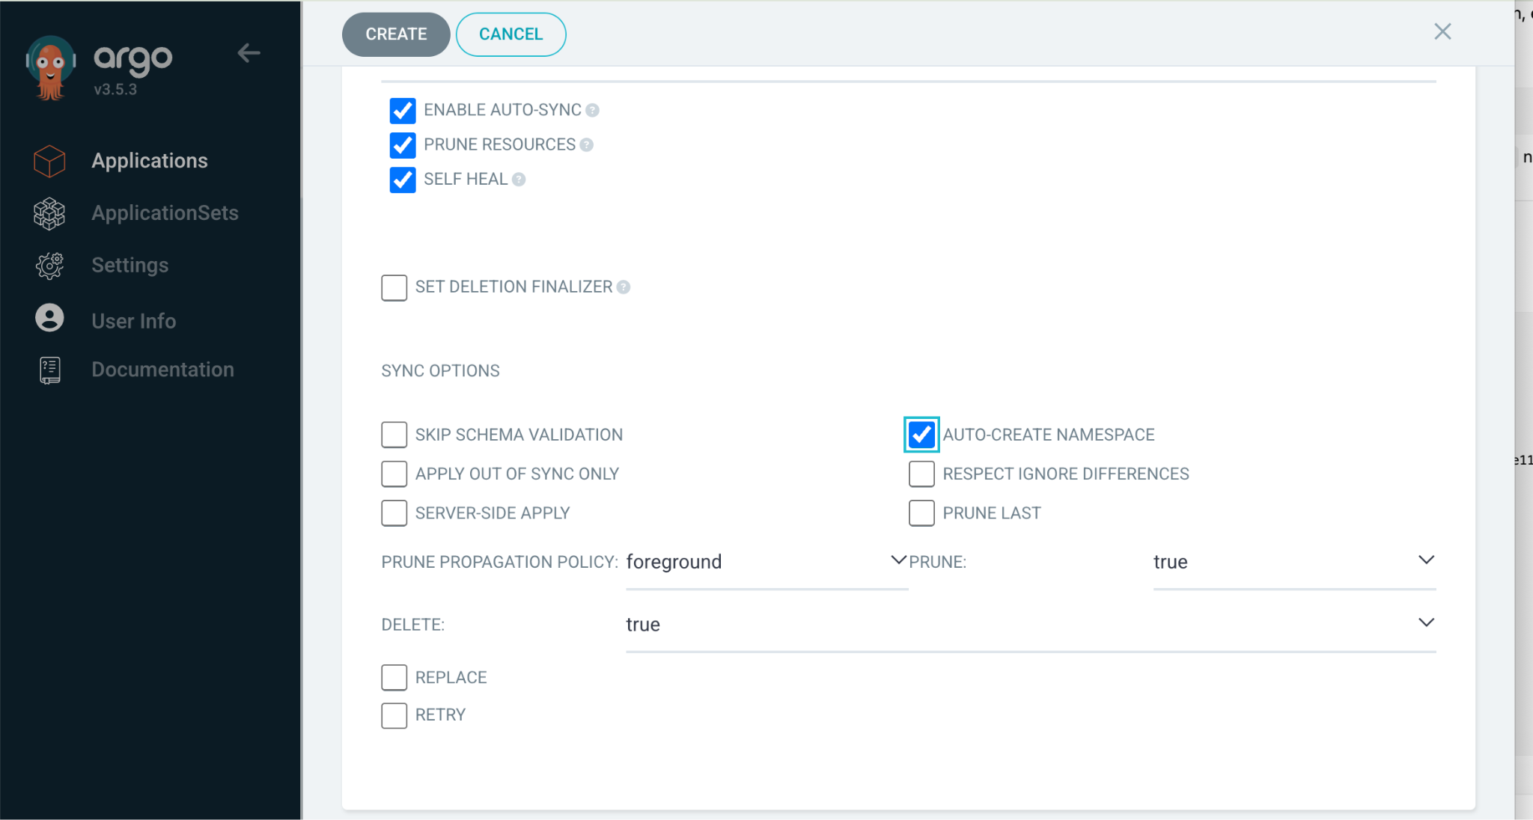

Final configuration :
Application
Name: gitops-nginx
Project: default
Sync: Automatic

Source
Repository: https://github.com/SnehalShinde11/gitops-nginx-app.git
Revision: master
Path: k8s

Destination
Cluster: https://kubernetes.default.svc
Namespace: gitops-nginx

Sync Options
CreateNamespace=true

Automatic Sync
Prune: Enabled
Self Heal: Enabled

Click Create. Once you click CREATE, don't manually run kubectl apply.

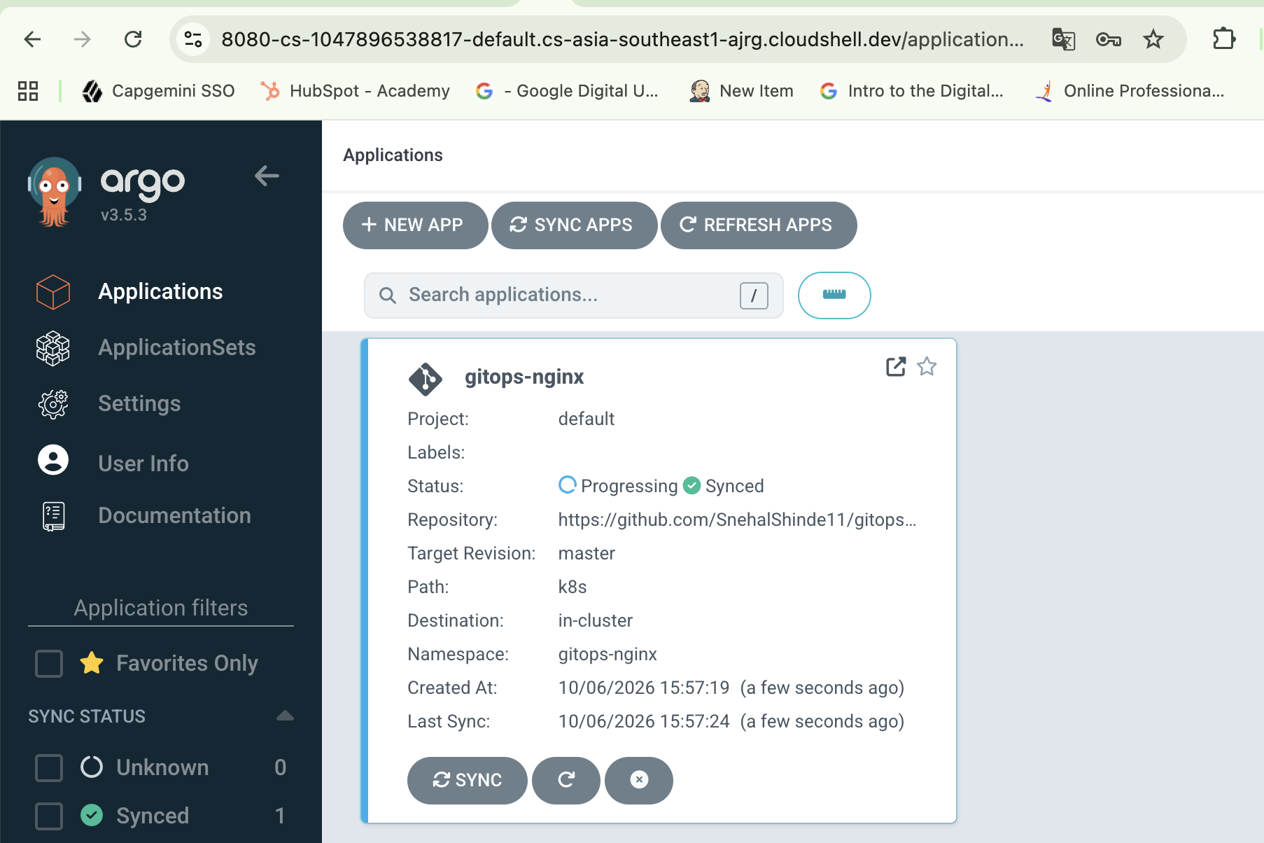
Wait until status is healthy and synced.
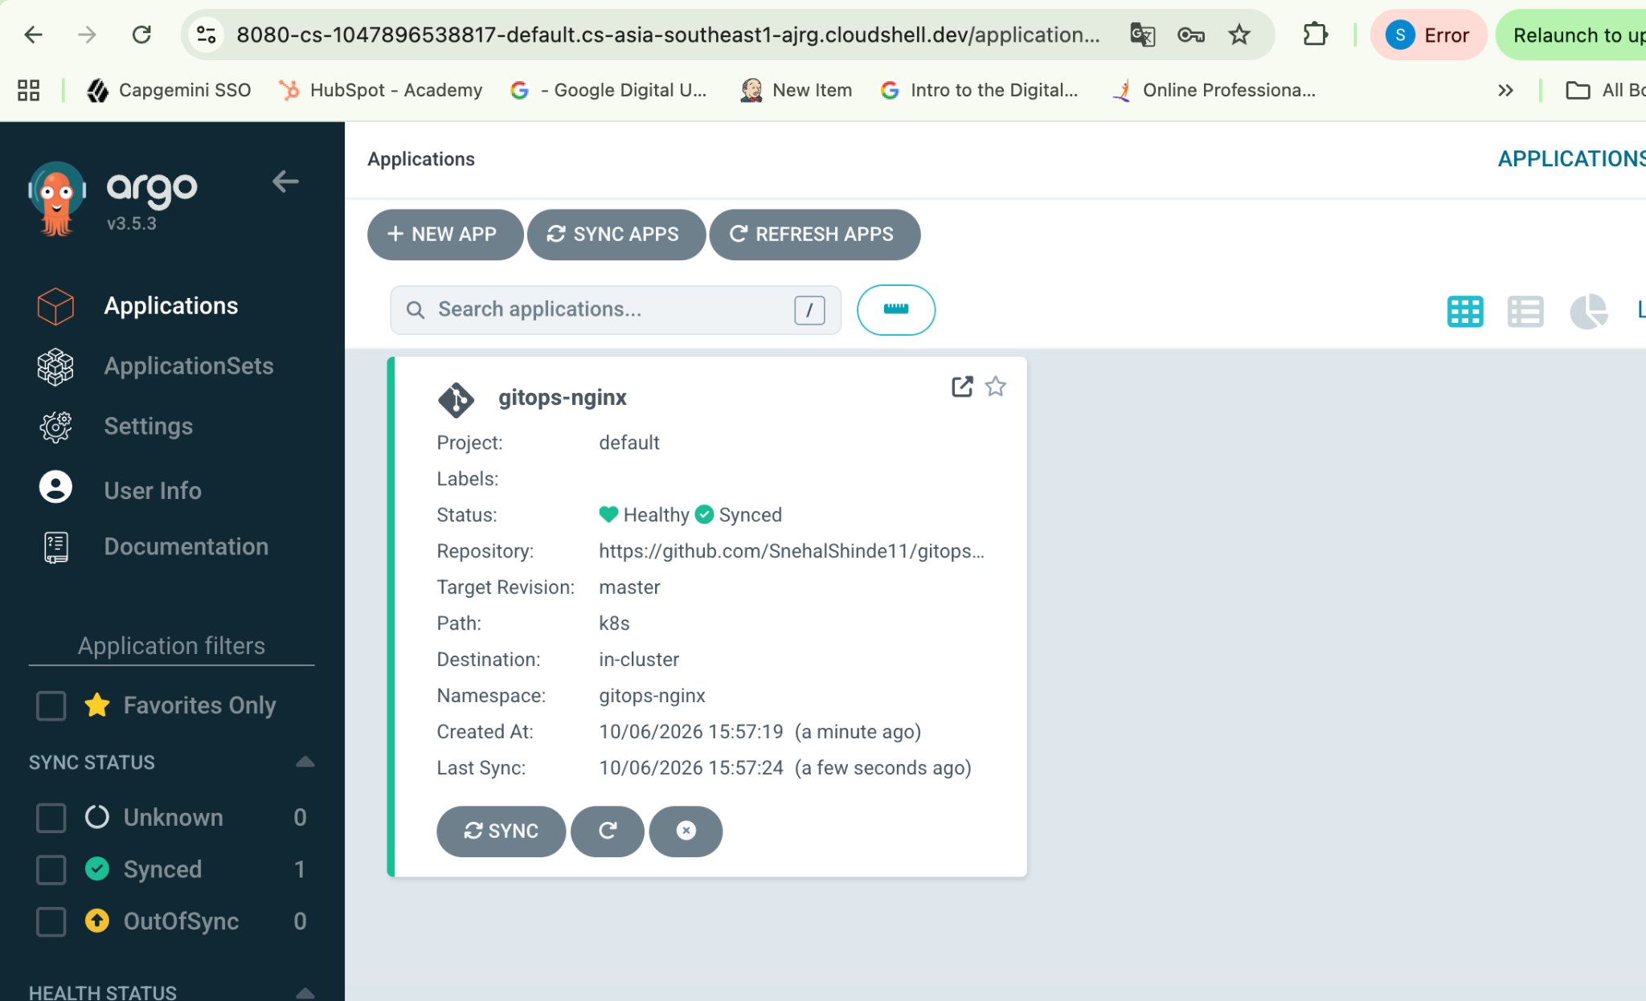

On
# kubectl get application gitops-nginx -n argocd
#kubectl get all -n gitops-nginx
#kubectl get pods -n gitops-nginx
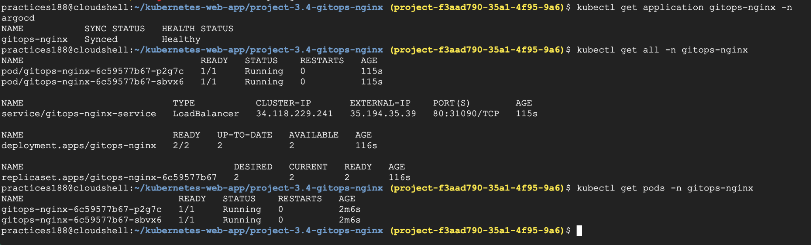

Let’s verify the application :
Let's also verify the actual Nginx application through the LoadBalancer.
Run:curl http://35.194.35.39
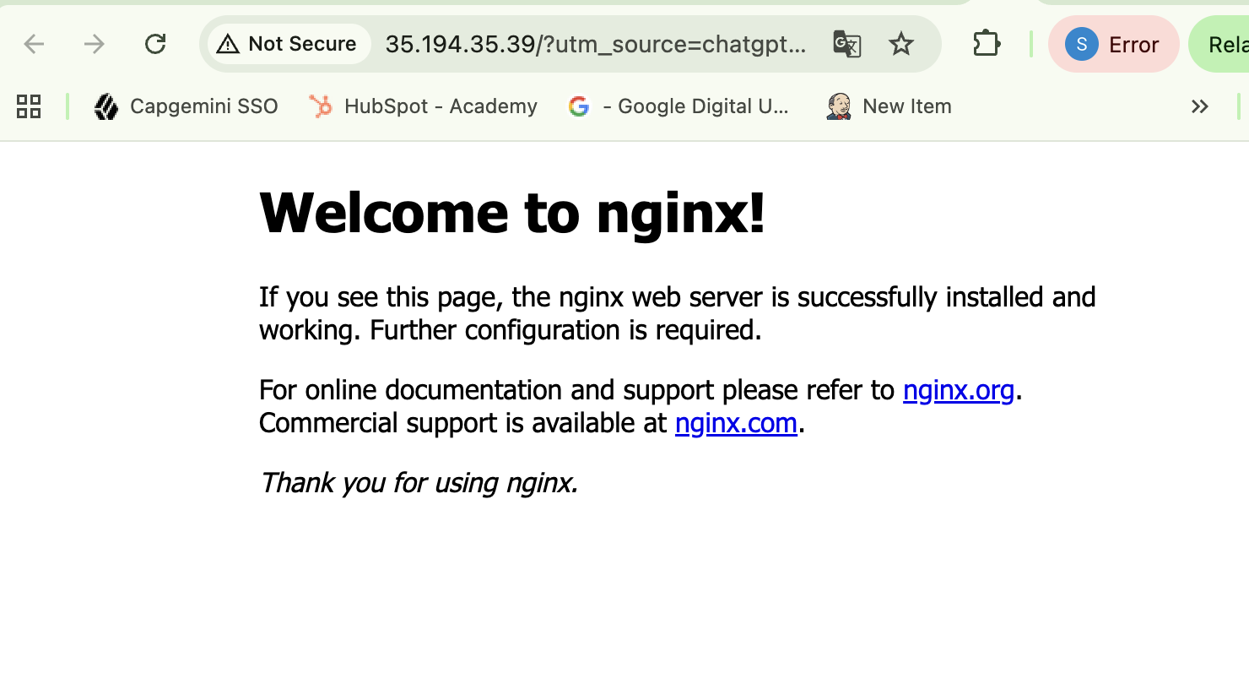

Task 5 - Deploy Application using GitOps
Trigger an application deployment by committing changes to the Git repository.
ArgoCD should detect the changes and automatically deploy the application to the Kubernetes cluster.

Task 6 - Verify Deployment
Verify that the application has been successfully deployed to the Kubernetes cluster.
Check the status of the application through the ArgoCD dashboard and Kubernetes resources.

Task 7 - Test GitOps Synchronization
Modify the application configuration in the Git repository.
Verify that ArgoCD automatically synchronizes the changes with the Kubernetes cluster.

Now for Task 5, Task 6 and Task 7 :
Let’s modify the replica count from replicas: 2 to 3.
Then push the change to GitHub and let ArgoCD automatically scale the application from 2 → 3 pods.

Before making change :
#kubectl get deployment gitops-nginx -n gitops-nginx
NAME READY UP-TO-DATE AVAILABLE AGE
gitops-nginx 2/2 2 2 8m2s

Open the deployment manifest:
spec: replicas: 2
Replace with count 3
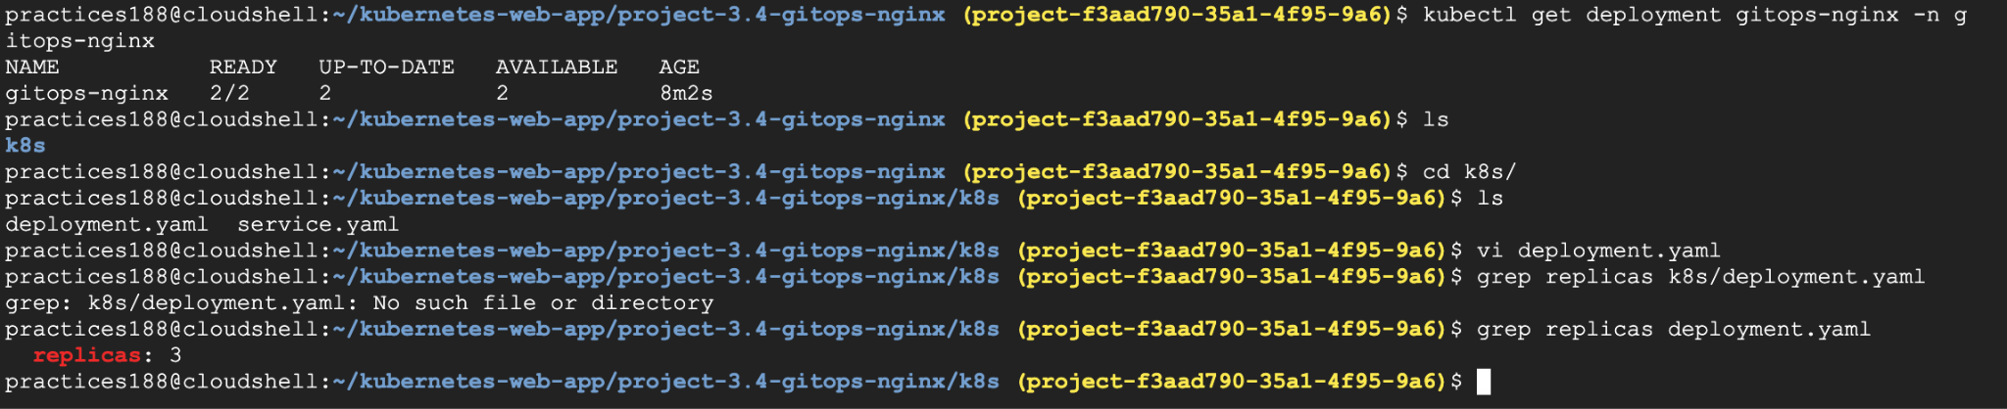
#git add k8s/deployment.yaml
# git status
#git commit -m "Scale GitOps Nginx to 3 replicas"
# git push

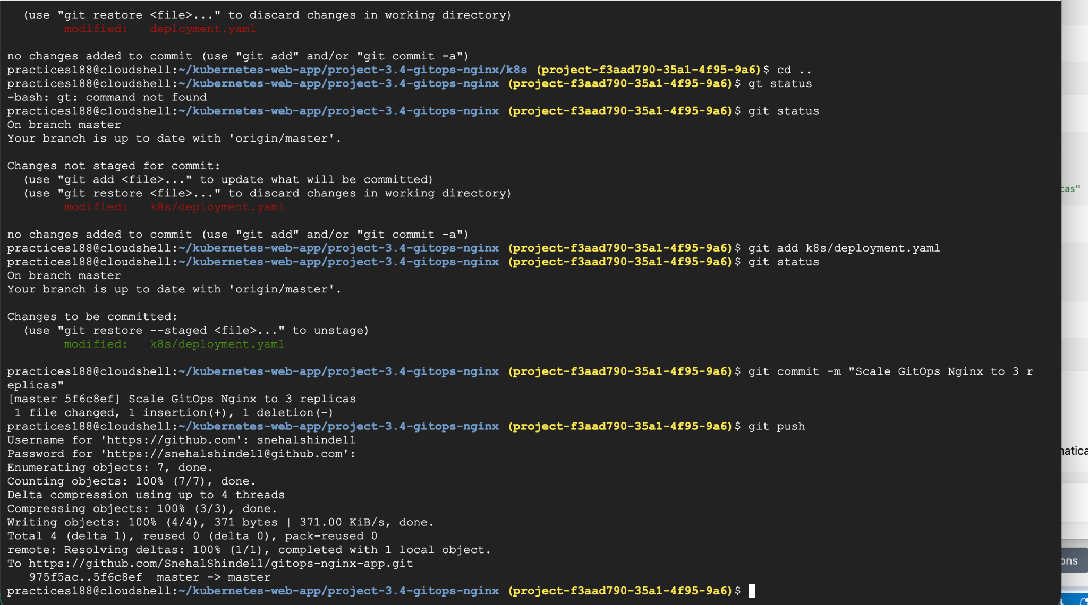

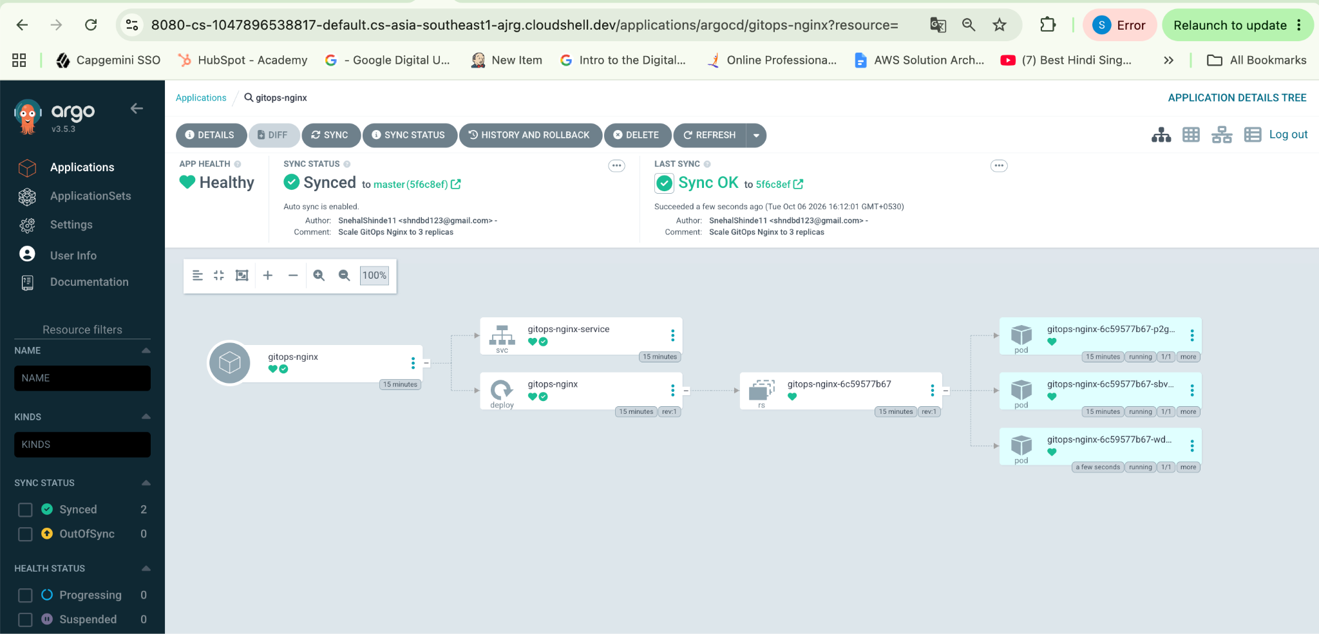
#kubectl get application gitops-nginx -n argocd
#kubectl get deployment gitops-nginx -n gitops-nginx
#kubectl get application gitops-nginx -n argocd
#kubectl get pods -n gitops-nginx
#history

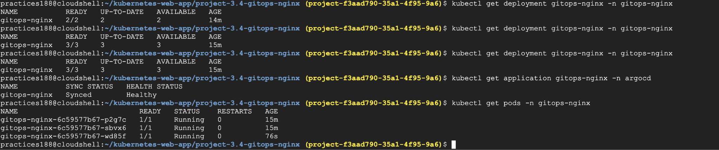
you changed only Git, and ArgoCD automatically reconciled Kubernetes.

Beyond the Basics - Elevate Exercise
Enhance the GitOps workflow by adding:
- ﻿﻿Enable automatic synchronization in ArgoCD

Task 1 — Enable Automatic Synchronization : We already selected Automatic Sync while creating gitops-nginx, but let's verify it from the Kubernetes side.
#kubectl get application gitops-nginx -n argocd -o yaml
Look for :
syncPolicy: automated:
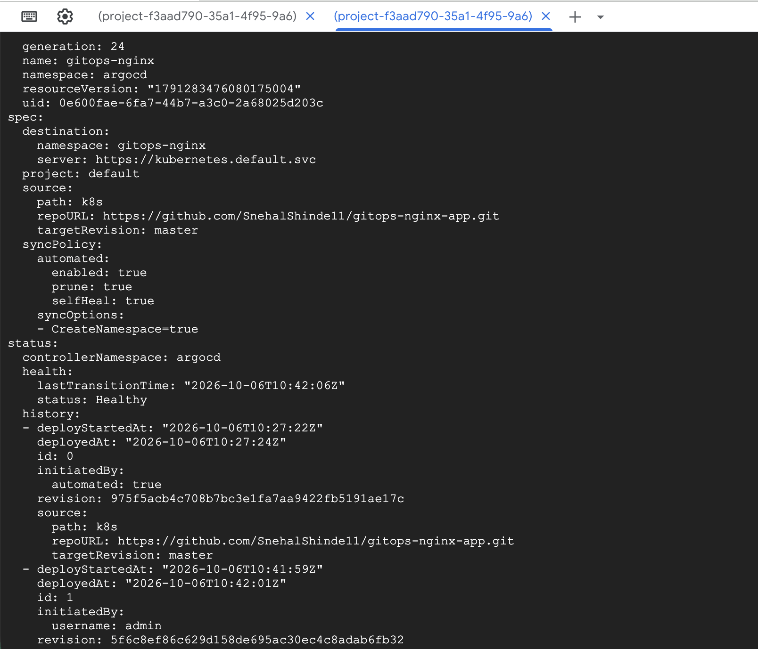

- ﻿﻿Configure application rollback using Git version history.
For GitOps, the recommended rollback mechanism is:
Git commit → revert to previous commit → push → ArgoCD automatically syncs
This is better than manually running kubectl rollout undo, because Git remains the source of truth.
Check current status :
#kubectl get deployment gitops-nginx -n gitops-nginx
#git log --oneline -2
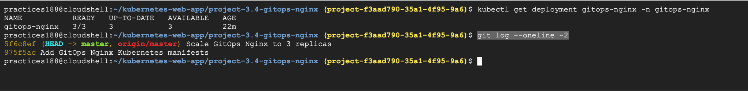
#kubectl get deployment gitops-nginx -n gitops-nginx
#git log --oneline -2
# cd ~/kubernetes-web-app/project-3.4-gitops-nginx
#git revert 5f6c8ef
#grep replicas k8s/deployment.yaml
#git push

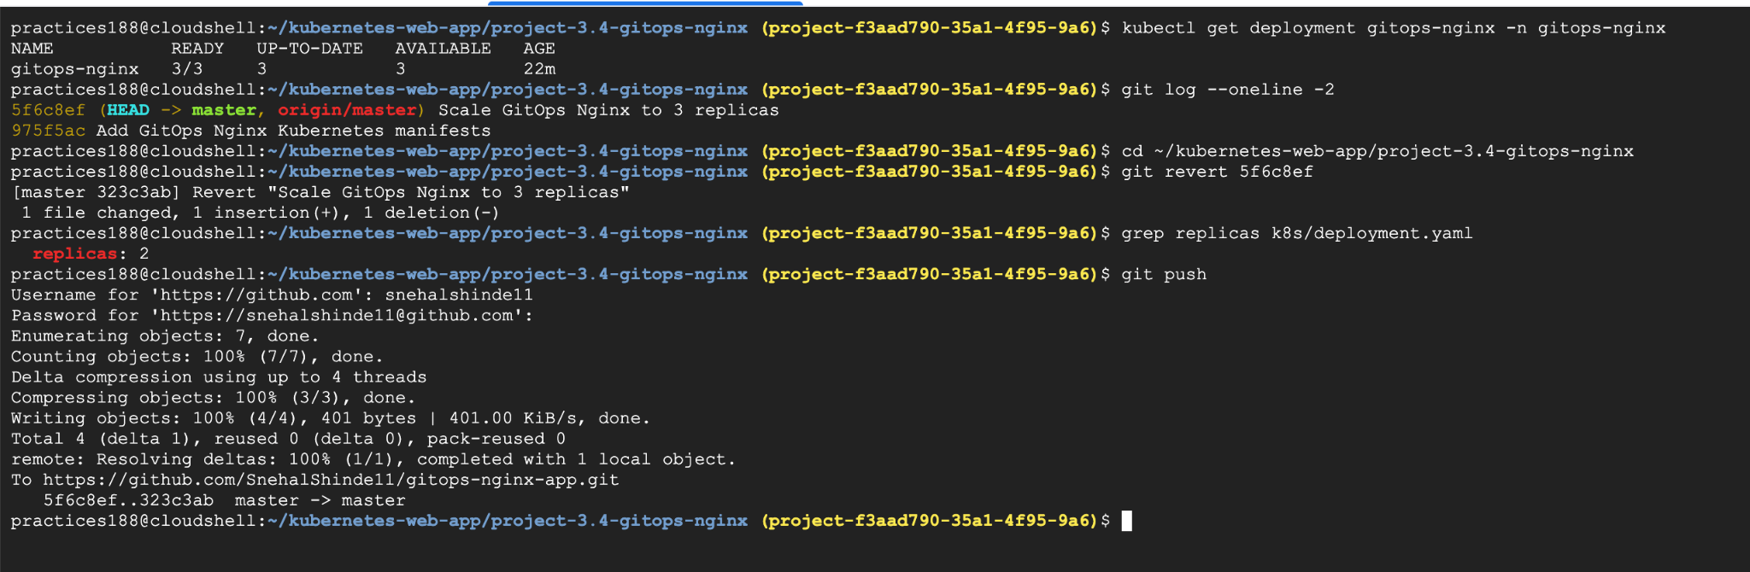
#kubectl get application gitops-nginx -n argocd
# kubectl get deployment gitops-nginx -n gitops-nginx
# kubectl get pods -n gitops-nginx

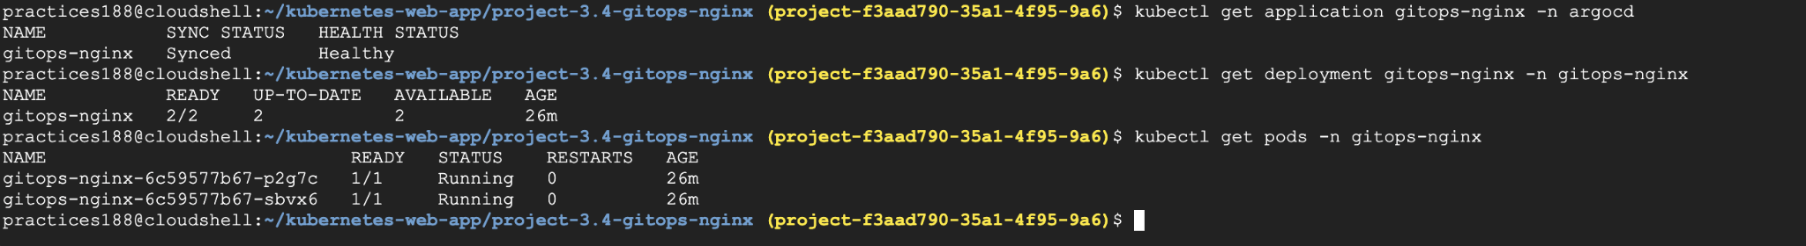
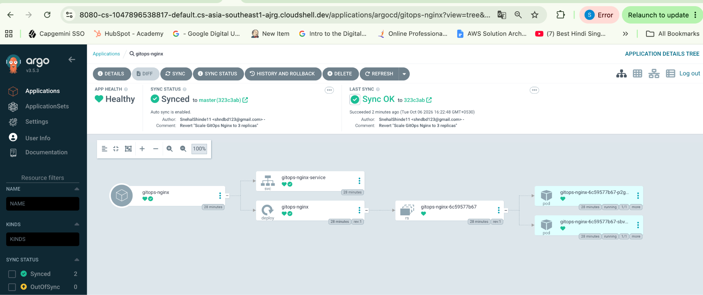
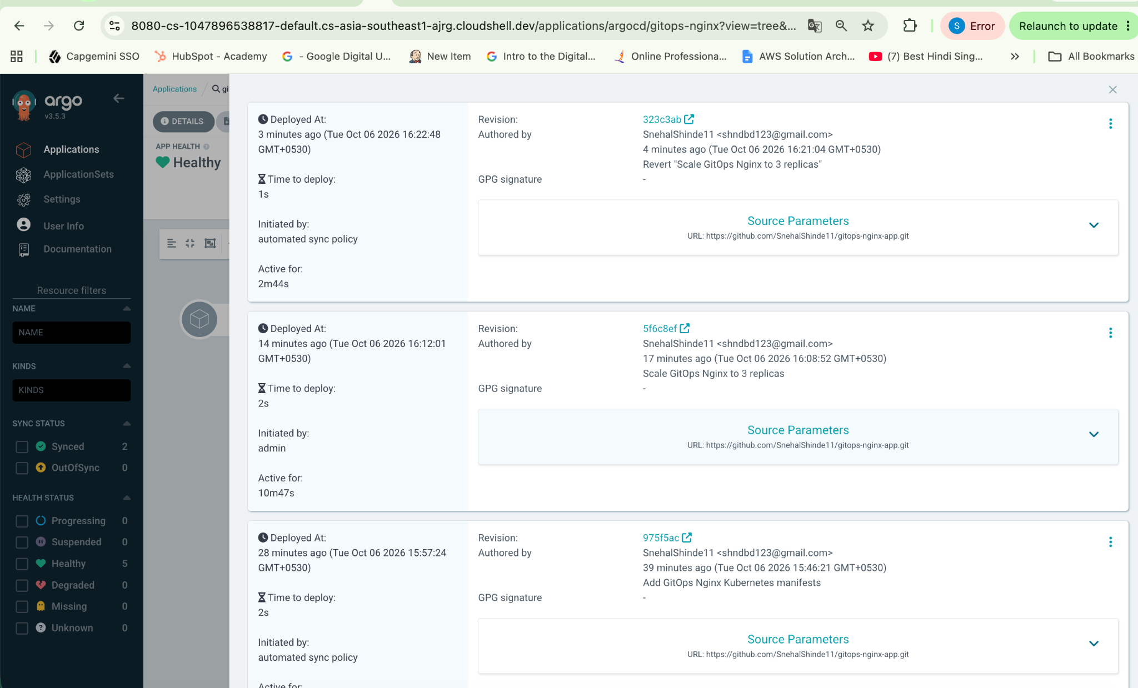
- ﻿﻿Deploy multiple applications using ArgoCD
- ﻿﻿Monitor application health from the ArgoCD dashboard
Let’s create another app :
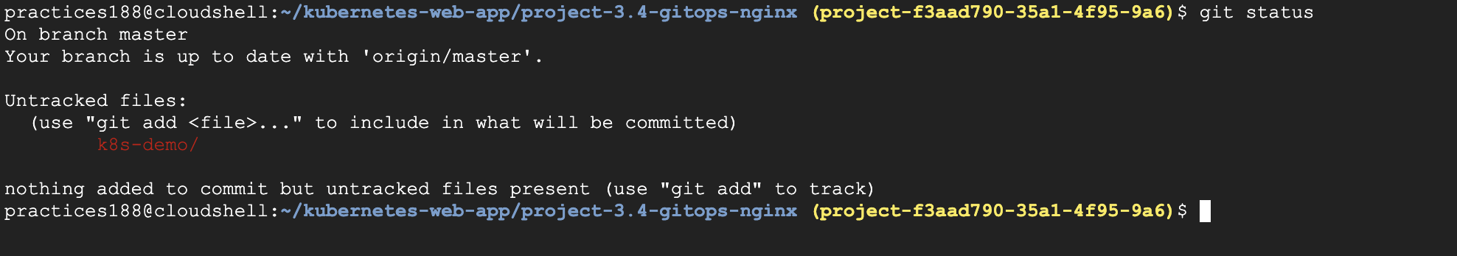
#git status
#git add k8s-demo/
#git commit -m "Add second GitOps Nginx application"
#git push

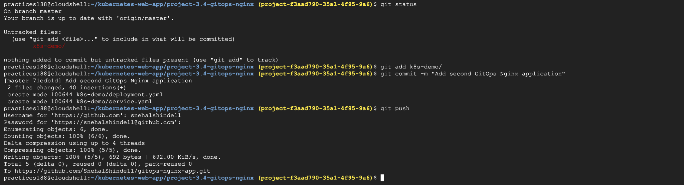

Create the second ArgoCD Application:
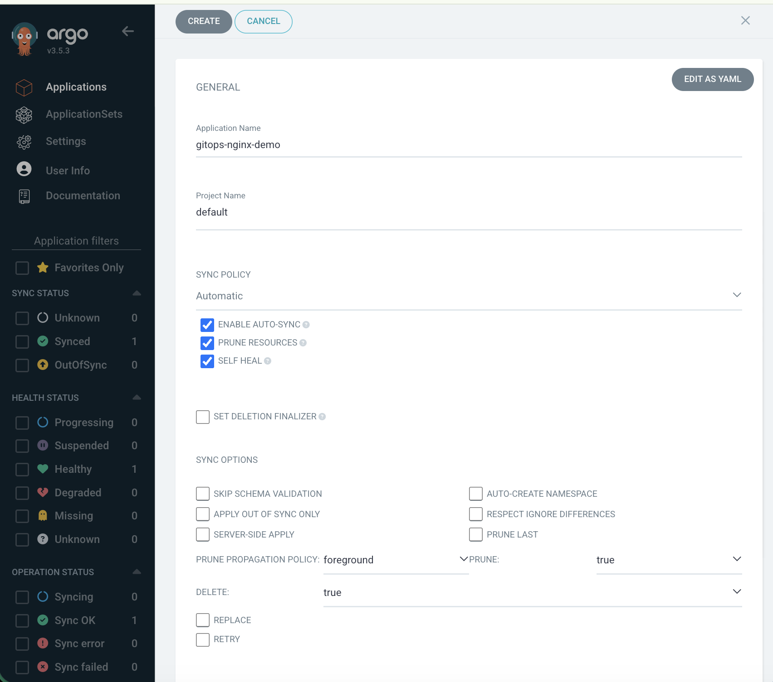
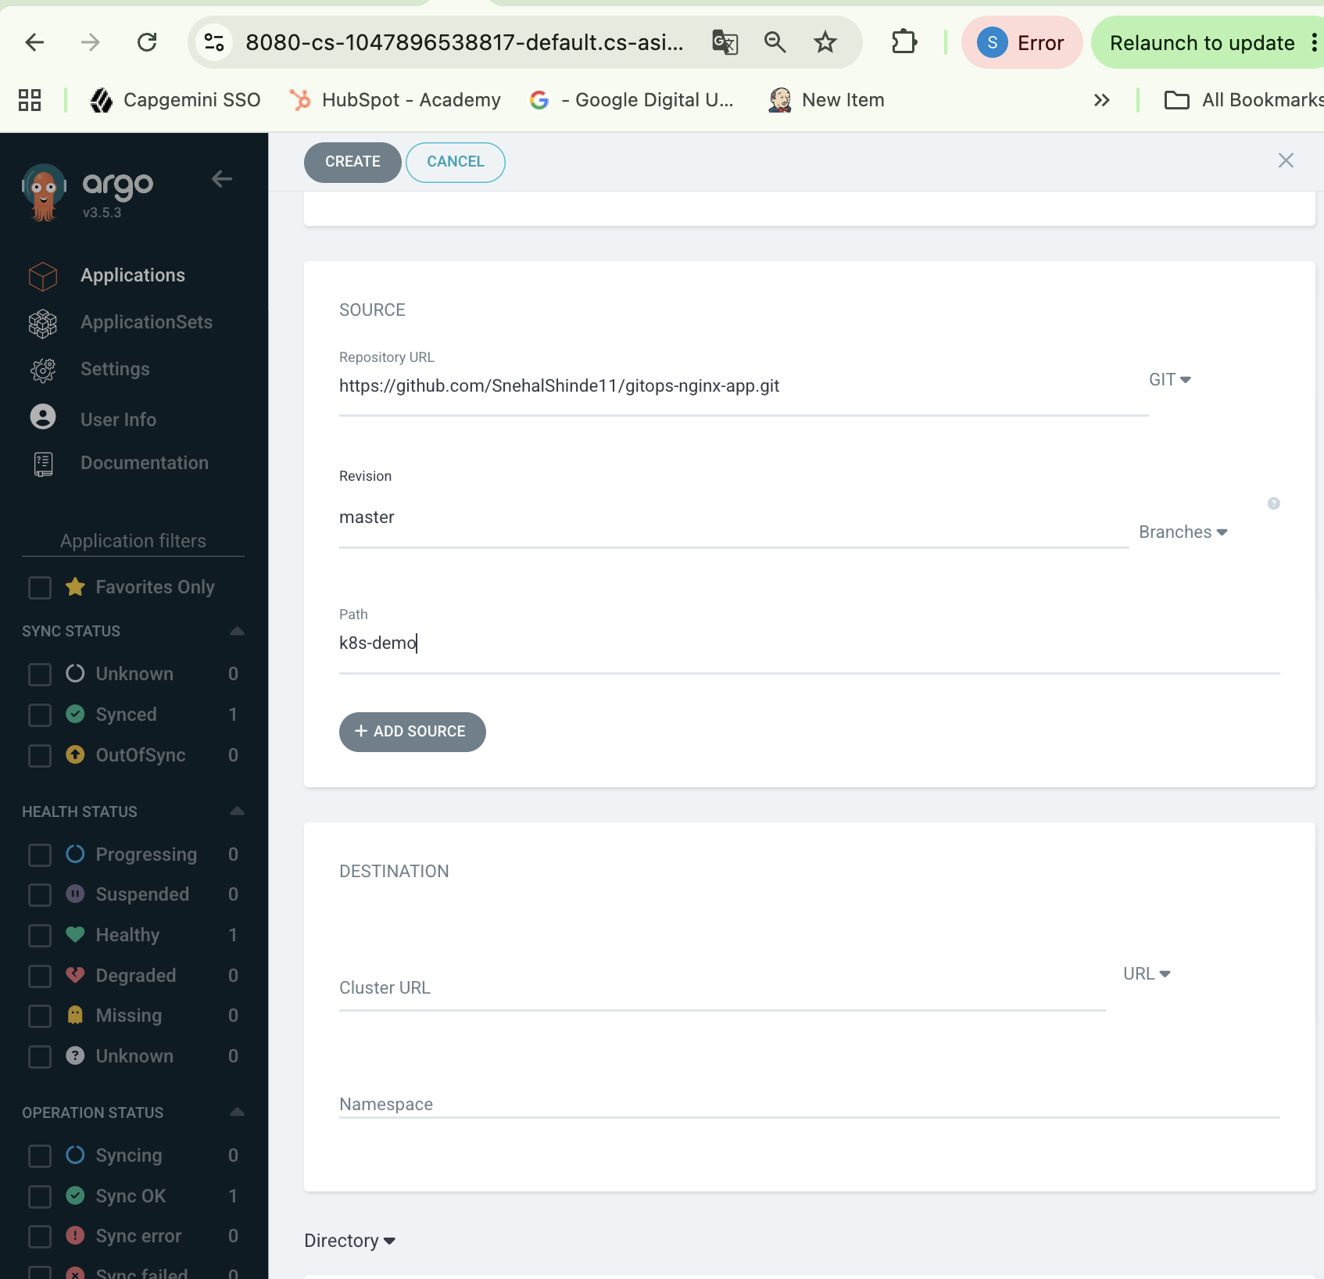
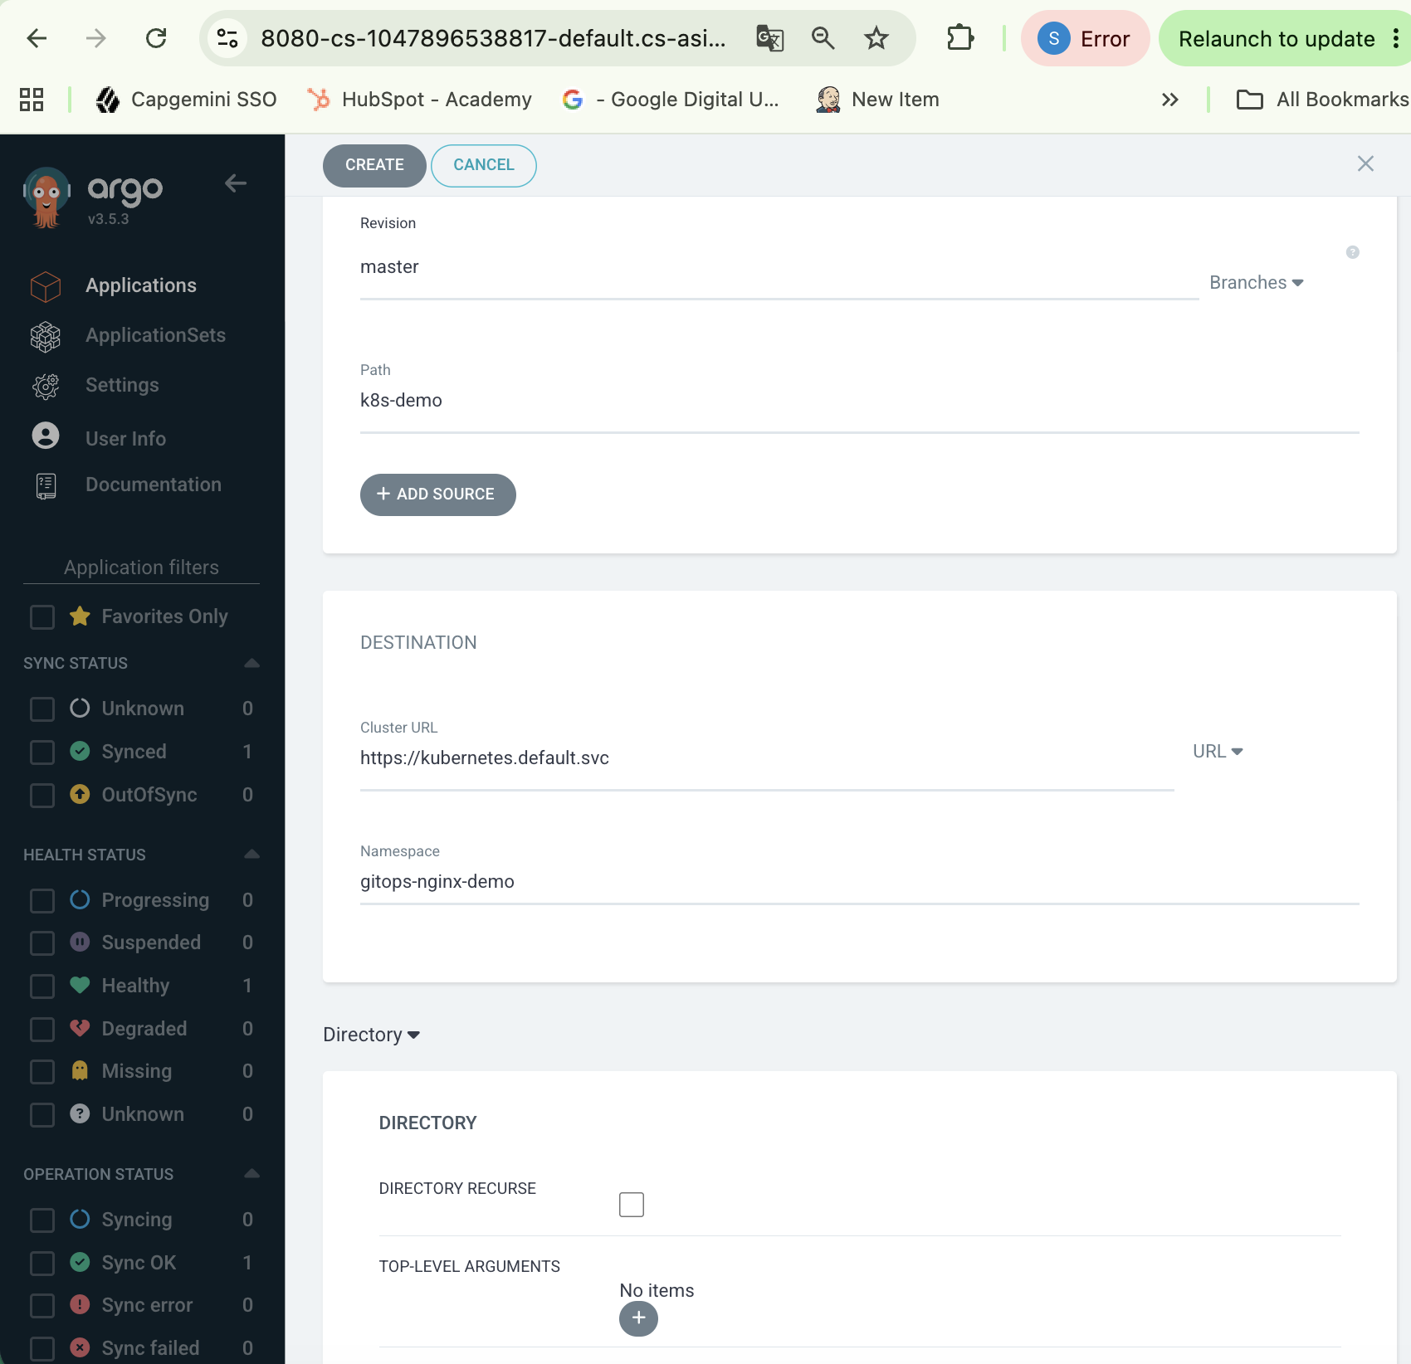
Click on create.
